# AVS 71 Call for Abstract E-mail Template

**E-mail Subject:** AVS 71 [YOUR TOPIC HERE] Call for Abstracts | Due August 25, 2025

**E-mail Body:**

**Add Banner:** [Use Your 1200 x 675 AVS 71 Call Banner Here] Download banner at: [**https://avs71.avs.org/promotion/**](https://avs71.avs.org/promotion/) and [Link it to Your Topic Page] or[**https://avs71.avs.org/**](https://avs71.avs.org/)

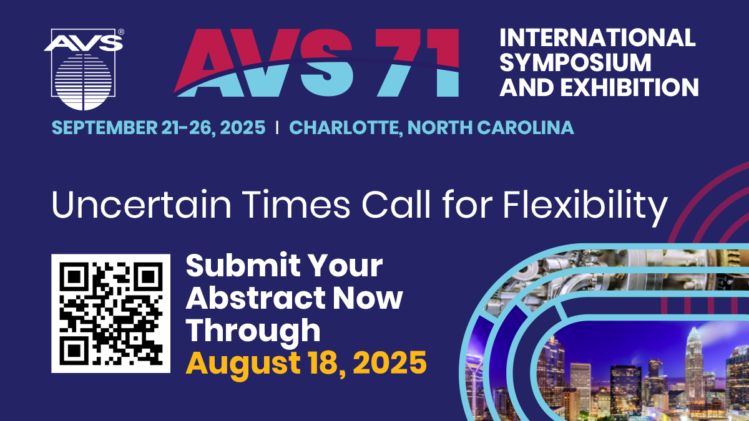

**Call for Abstracts Deadline: August 25, 2025**

**“Engineering the Future: Collaborative Frontiers in Surface, Quantum, and Energy Sciences”**

*Featuring Presentations on Emerging Topics Related to Materials, Processing & Interfaces*

Technical & Poster Sessions - Mini Symposia – Exhibits Professional Development - Career Services - Training

Dear [Insert Name],

The AVS International Symposium and Exhibition will address cutting-edge issues associated with materials, processing, and interfaces in both the research and manufacturing communities. The weeklong Symposium this September 21-26, 2025, in Charlotte, North Carolina fosters a multidisciplinary environment that cuts across traditional boundaries between disciplines, featuring papers from AVS Technical Division, Groups, Focus Topics on emerging technologies and more. [Insert Specifics About Your Call and a Link to Your Topic Page].

**Things to Customize and Highlight (Learn More at** [**https://avs71.avs.org/promotion**](https://avs71.avs.org/promotion)**)**

* **Your Special Sessions, Invited Speakers, or Committee Members:** Highlight your special sessions and invited speakers and/or your committee members to potential attendees. Remind them about the friendly and multidisciplinary nature of AVS.
* **Awards & Travel Grants:** Remind potential attendees about awards opportunities for your specific division/group/focus topic as well as the [**AVS Professional and Student Awards**](https://avs.org/awards/)**.**
* **Exhibit & Special Events:** Don’t forget to mention the [**equipment exhibit**](https://avs71.avs.org/vendor-exhibit/) as well as all the other special events and networking opportunities during AVS 71. An extensive Exhibition of related equipment, tools, materials, supplies, chemicals, services, consulting, technical literature, and new technologies are showcased during the week.
* **Benefits of Attending: Inform** potential attendees about the benefits of attending: [**Why Attend AVS 71 Video**](https://www.youtube.com/watch?v=xUAboGKzXH0) and [**Why Attend AVS 71 Flyer**](https://avs.org/AVS/media/Files/Press-Media/Why-Attend-AVS-Symposium.pdf)

**Submit Your Abstract by August 25, 2025, at** [**https://avs71.avs.org/**](https://avs71.avs.org/)

**Questions?** [Insert Your Name and E-mail]